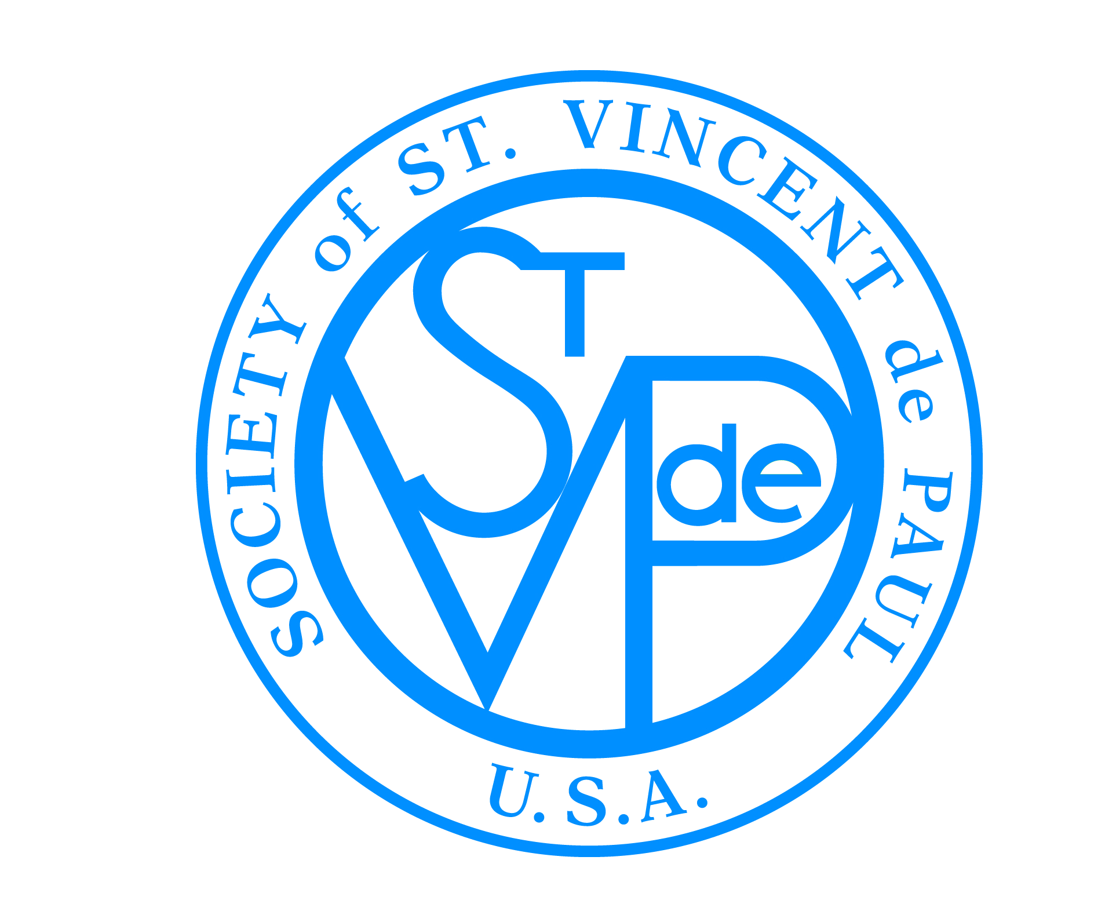

FRIENDS OF THE POOR® WALK/RUN
SOCIETY OF ST. VINCENT DE PAUL
®

Friends of the Poor® Walk/Run
Media Advisory Template – Copy from Below

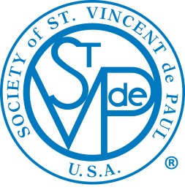
Media Advisory

For release: Media inquiries only:
Date Name of Contact Person
Phone: (xxx) xxx-xxxx
Cell: (xxx) xxx-xxxx
Email:

WHAT: 12th Annual Friends of the Poor® Walk/Run, to benefit those in need and living in poverty in the insert name of City here area.

WHEN: Insert event date here
Registration begins at time a.m., and the walk starts at time a.m.

WHERE: Location
Street Address
City, State, Zip Code

WHO: The Insert Council or Conference name here of the Society of St. Vincent de Paul (SVdP). One of the largest charitable organizations in the world, SVdP is an international Catholic lay organization of approximately 800,000 men and women who voluntarily join together to grow spiritually and offer person-to-person aid to needy and those living in poverty in 155 countries on five continents. The Insert name of Council or Conference here of SVdP serves [number] individuals in need, volunteered [number] hours, and raised [approximate dollar amount] to help people in need throughout the area regardless of religion, race or national origin.

WHY: The U.S. Census Bureau reports that nearly 40 million Americans (about 12 percent of the population) are living in poverty. The poverty rate for children under age 18 is 18 percent. Poverty also affects people in the Insert name of city here area.

The Friends of the Poor® Walk/Run is a simple, visible way to help bring attention to the issue and help raise funds to help those in need in our community. Unlike similar events, with the Friends of the Poor® Walk/Run, every dollar raised will directly benefit the people in the Insert name of City here area.

Note: You are invited to send a reporter, photographer or camera crew to the event.

# # #

